

Process: Controller Information Sheet and Personality
Updated 16th June 2023

Overview
This document specifies the recommended testing and documentation involved in developing Controller Information Sheet (CIS) and personality software (SFT) for all traffic signal controllers in New Zealand.
All forms and templates involved in checking and testing are available at snug.org.nz

Procedure
The key stages involved in CIS and SFT development, and the required forms to be completed, are:
# | Stage | Typically completed by | SNUG form required
1a | Design | Traffic signal design consultant | Design summary proforma OR note on design plans
1b | Design acceptance | RCA or representative
2a | CIS development | Specialist
2b | CIS checking | Specialist (independent of CIS developer) | CIS check sheet
2c | CIS acceptance | RCA or representative
3a | SFT development (based on approved CIS) | Specialist
3b | SFT testing using controller simulator software (“WinTraff”) and SCATS testing (if required) | Specialist (independent of SFT developer) | SFT test sheet
3c | SFT bench test | Contractor | Controller bench test form
4a | Installation and testing | Contractor / RCA or representative
4b | Construction sign off | RCA or representative | SAT form

The above procedure is also shown below as a flow chart:
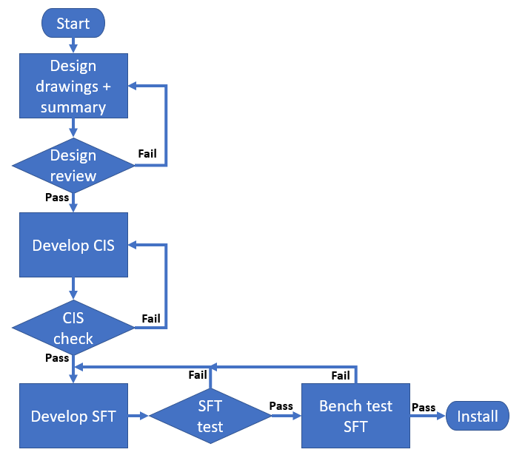

Background
All traffic signals in NZ require a Controller Information Sheet (CIS) and controller personality (SFT). The CIS and SFT will be unique to the site and details how the site is to operate.
Controller Information Sheet (CIS)
This is a technical document that specifies the controller functionality, operation, and time settings. It is primarily used to develop the controller personality; but is also used by
- the traffic signal contractor during site installation, maintenance, and bench testing; and
- by SCATS operators in configuration and day-to-day operation.
- The personality developer
The types of information contained in a CIS include layout, phasing, signal group configuration, detector numbering and operation, time settings, a conflict matrix, and any special logic.
To develop the CIS a detailed design drawing is required which should include phasing design, signal group and detector numbering, the types of display to be installed for each movement, and the type of pedestrian protection required. Any special features (logic) should be included in the notes on the drawing or alternatively in a Design Summary (Proforma) for incorporation into the CIS.
Controller personality (SFT)
This is a file with a *.sft extension (sometimes referred to as “software”) containing coded information instructing the traffic signal controller to operate as specified by the CIS. The file is generated using a tool developed by SCATS Australia, into which the information in the CIS – including any custom code required – is programmed. Code is written in a proprietary format with the resulting SFT file able to be read by either the traffic signal controller or a controller simulator.

CIS and SFT Development
Formatting of the CIS and SFT is a specialised field and it is common for these documents to be completed by a specialist who was not the signal designer. This creates the potential risk that specific functionality intended by the designer may not be known to the CIS developer. Therefore the recommended process is that the traffic engineering consultant who develops the design either:
- Includes operation notes on the drawings, or:
- Completes the SNUG Traffic Signal Design Summary Proforma
The Design drawings and operation notes/proforma should be provided to the CIS developer for review.

Checking & Testing
Checking (also known as reviewing) of the CIS and testing of the software should be done by an independent experienced signals practitioner. Both the CIS & SFT should be checked, with a CIS / SFT test sheet completed as evidence.
The SFT testing should confirm that the software complies with the operation/functionality as specified in the CIS and involves testing the SFT in a simulator (a tool called “WinTraff” developed by SCATS Australia). This includes testing that the signal groups operate in the correct phases, operation of overlapping movements, detectors call/extend the correct phases, pedestrian/cycle protection, and any other special features specified. Testing may include SCATS testing, if appropriate for functionally.
Bench testing of the SFT checks that the software runs correctly on a physical controller and is completed by the signals contractor, who completes the Controller bench testing form.
The bench test should also ensure all conflicts are proven by physically inducing conflicts within the controller (and the person doing the bench testing should confirm that the conflict matrix as provided in the CIS is correct).
Installation of the software should not occur at the site until all testing has been completed and the software is operating in the manner specified in the CIS and that the operation is safe. When the new software is installed, prior to the traffic signals being commissioned, a full “flash test” should be completed as part of the Site Acceptance Test which ensures the signals have been built in accordance with the national traffic signal specification.

Naming Convention
Updates to the CIS and SFT should be tracked by updating the naming each time the CIS and SFT are modified.
The naming convention should be as follows:
- CIS: Example: V2b. the number indicates major revisions, the letter indicates minor (e.g. review) revisions and the letter increases each time the CIS is modified.
- SFT: Example: V2bc. This matches the CIS version, with an extra letter added for the SFT version which increases every time the SFT is modified.

